Useful Contacts
As well as your class teacher, Mrs Hope (SENco) or Mrs Taylor (inclusion Coordinator) will be more than happy to see you.
CDA: Cornwall Dyslexia Association
01872 222991
www.cornwalldyslexia.org.uk
BDA: British Dyslexia association
www.bdadyslexia.org.uk

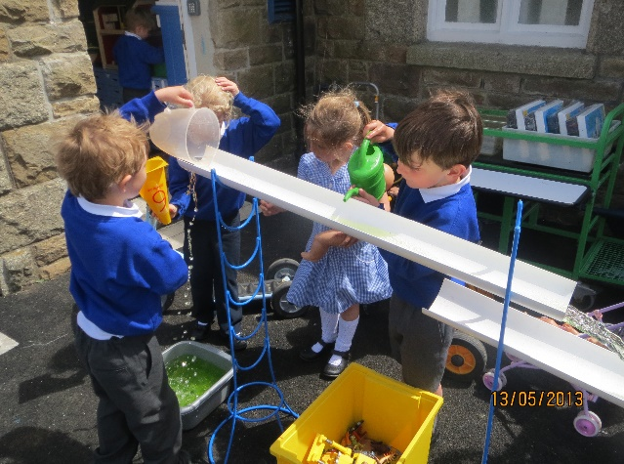

At St Mary’s Church of England School we see ourselves as all being teachers of children with special educational needs. As such St Marys C of E School adopts a ‘whole school approach’ which involves all the staff adhering to a model of good, inclusive practice. The staff of the school are committed to identifying and providing for the needs of all children irrespective of need.

Dyslexia

Special Education Needs and Disabilities

St. Mary’s Church of England Primary School

This is a leaflet on Dyslexia Spectrum Learning differences and how they are accessed at St Mary’s Church of England Primary School, as well as where to find additional help, support and guidance.

What is Dyslexia?
There are lots of different definitions of dyslexia. Here at St Mary’s C of E School, we understand that:
“The word ‘dyslexia’ comes from the Greek meaning ‘difficulty with words’ and is a difference in the way the brain processes language” (The Cornwall Dyslexia Association)
Dyslexia is a specific learning difficulty which mainly affects reading and spelling. About 10% of the population are affected by dyslexia to some degree. Dyslexic pupils frequently have weaknesses in short term memory, sequencing and the speed of processing information – all important skills in a busy classroom.
However, these skills are not linked to intelligence. There is evidence that many dyslexic people have strengths and abilities in tasks that involve creative and visually based thinking.

How are Children Identified?
At school, children are monitored very closely for progress and understanding at every stage of their learning from their very first day at school.
Children are supported in school with dyslexia friendly strategies in lessons. If there are concerns at school, or at home, that your child maybe displaying dyslexic tendencies following steps will happen;

- A meeting between parents and class teacher to discuss concerns
- A meeting with the parents/Class teacher and Senco
- A DST will be completed in school (Dyslexia screening test) by the SENCo or Inclusion coordinator.
- A meeting with the parents and teachers to discuss outcome of the DST and how to work best to support your child.

Did You Know?
- Some famous Dyslexics are; Bill Gates, Albert Einstein, Walt Disney, Roald Dahl
- Dyslexia is far the most common learning disability
- Dyslexics often enjoy and excel at solving puzzles.
What to look for
- Forgetfulness, particularly short term auditory memory
- Poor concentration
- Slow Processing speed
- Poor handwriting, usually spelling.
- Poor phonological abilities
- May have better developed areas such as art, drama.
- Inconsistent, may have good or bad days, disorganised.
It is important to note that many children may show some of these indicators at a young age: this does not necessarily mean they are Dyslexic.

