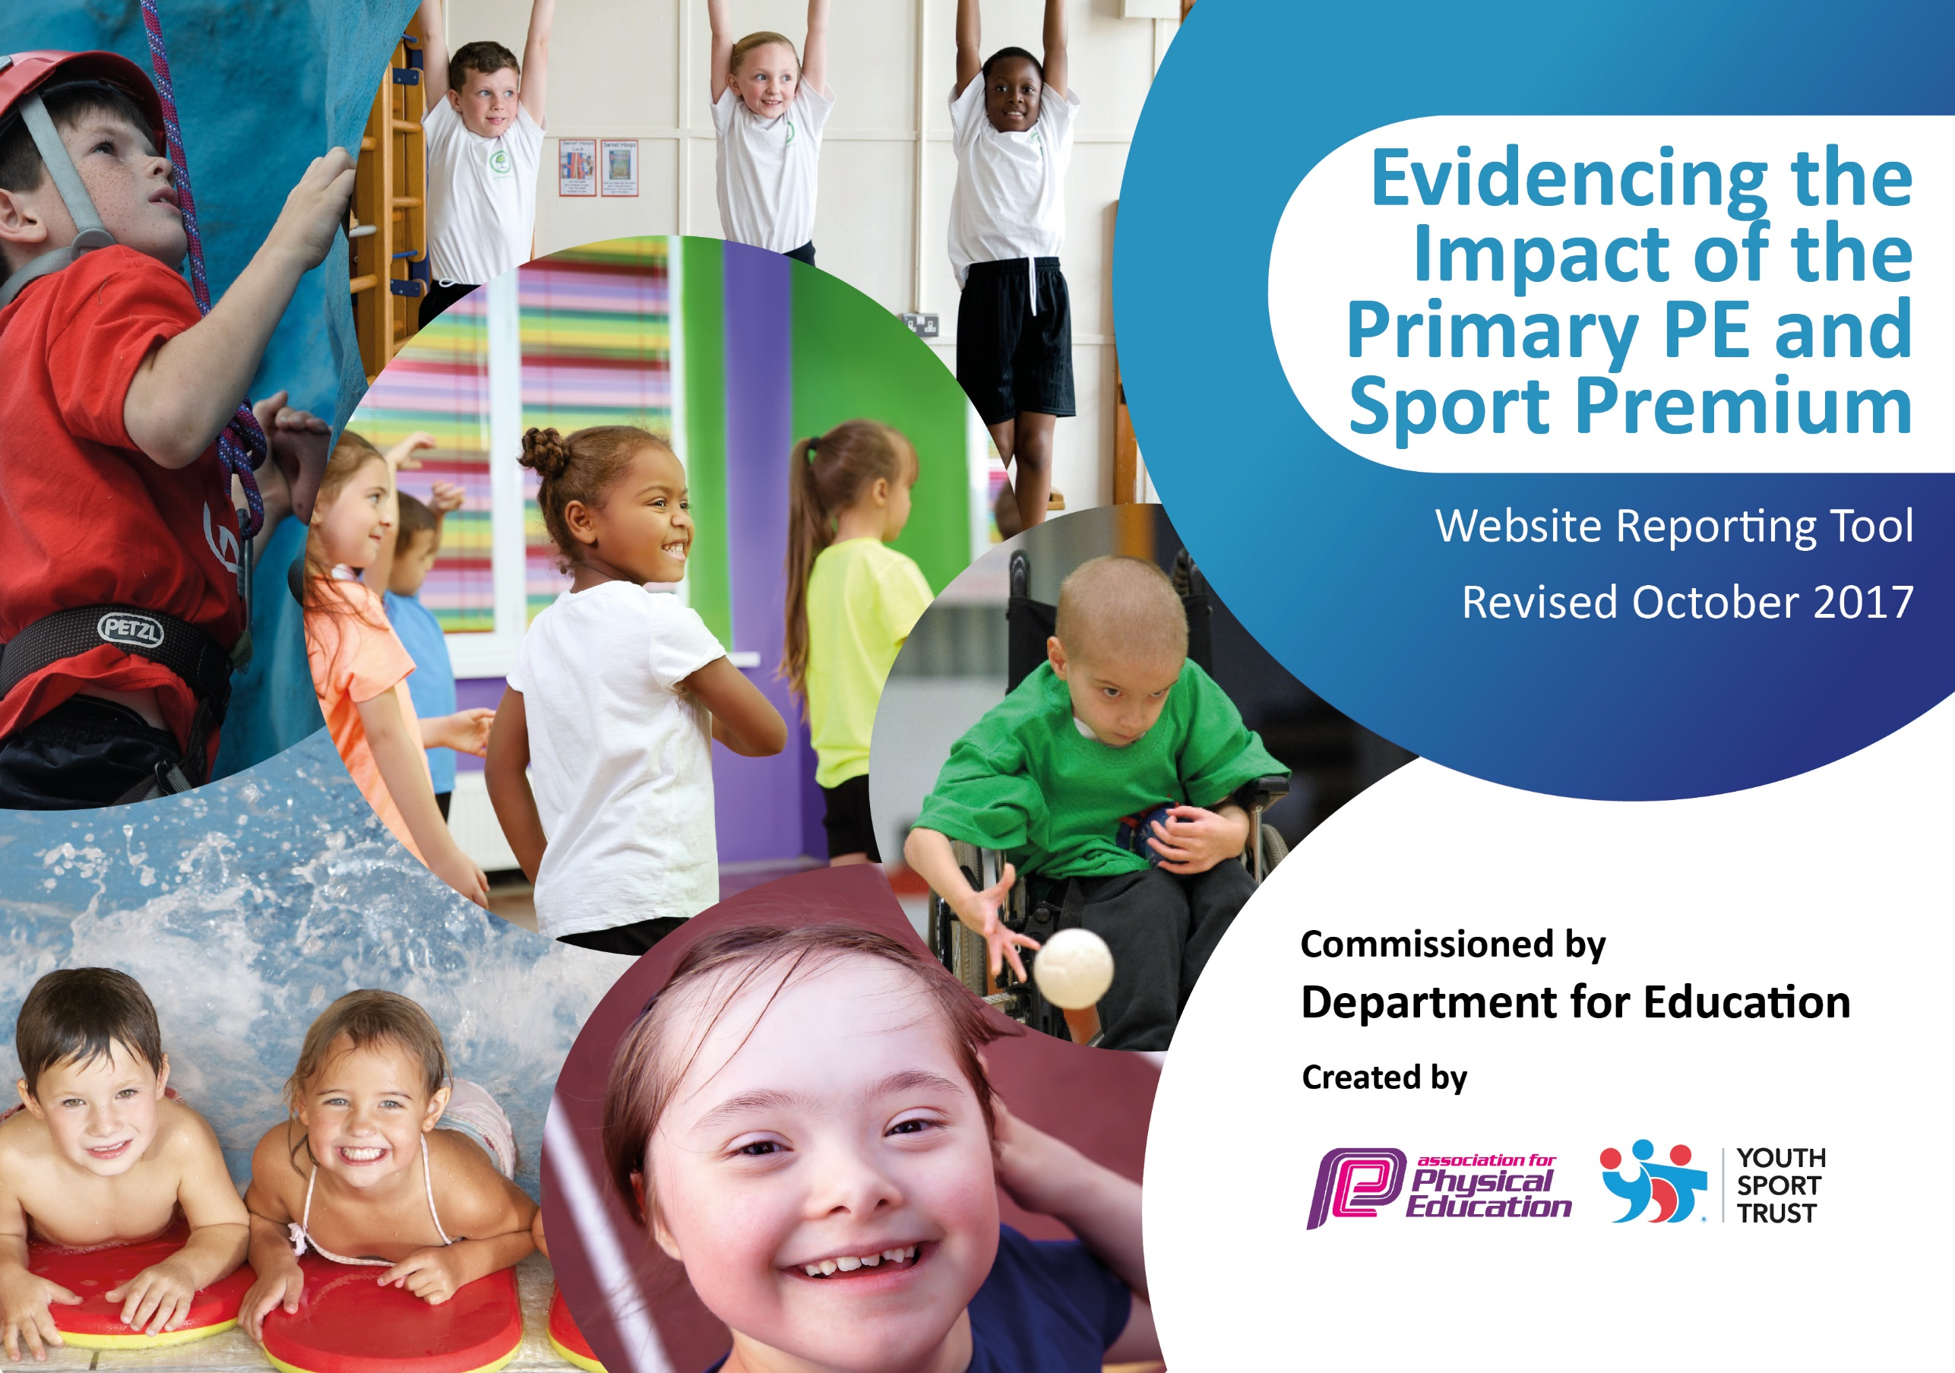

Schools must use the funding to make additional and sustainable improvements to the quality of PE and sport they offer. This means that you should use the Primary PE and Sport Premium to:

- develop or add to the PE and sport activities that your school already offers
- build capacity and capability within the school to ensure that improvements made now will benefit pupils joining the school in future years

Please visit gov.uk for the revised DfE guidance including the 5 key indicators across which schools should demonstrate an improvement. This document will help you to review your provision and to report your spend. DfE encourages schools to use this template as an effective way of meeting the reporting requirements of the Primary PE and Sport Premium.

We recommend you start by reflecting on the impact of current provision and reviewing the previous spend.
Under the Ofsted Schools Inspection Framework, inspectors will assess how effectively leaders use
the Primary PE and Sport Premium and measure its impact on outcomes for pupils, and how effectively governors hold them to account
for this.

Schools are required to publish details of how they spend this funding as well as on the impact it has on pupils’ PE
and sport participation and attainment.
We recommend regularly updating the table and
publishing it on your website as evidence
of your ongoing review into how you are using the money
to secure maximum, sustainable impact. To see an example of how to complete the table please click HERE.

Support for review and reflection - considering the 5 key indicators from DfE, what development needs are a priority for your setting and your students now and why? Use the space below to reflect on previous spend, identify current need and priorities for the future.

Key achievements to date: | Areas for further improvement and baseline evidence of need:
All children (F-Y6) are now having swimming lessons (Minimum 12 sessions per year)  We came 3rd in the school Gala out of 16 school in Penwith. The 1st time we had been in the top 10.  Last year, was the first time our school reached county level (Level 3, Cornwall School Games) in any sport.  6 of our sporting teams reached county level competition for, badminton, dance, indoor athletics, cross country and tennis.  At county level, we achieved:  Y5/6 Badminton won GOLD  Y3/4 Badminton came 3rd  Y5/6 Dance SILVER medal  Y3/4 Tennis GOLD in plate.  For the 1st time, we competed in the Netball and hockey leagues. Our hockey and netball teams came 3rd in their leagues, narrowly missing out on the next stage.  The children were introduced to new sports which include; lawn bowls, grass cycling, balanaceability and surfing.  We had our greatest participation in afterschool sports clubs with an increase of 42% from previous years. We did this with an increase in the range of clubs across the key stages. | To enhance the participation of girls in upper ks2 sport.  To enhance the support/participation of vulnerable groups in sports clubs.  To provide CPD for teaching staff in gymnastics and dance.  To provide CPD for lunchtime/ breakfast club staff to enhance physical exercise of all children.  To train playground leaders who can lead sport in the playground and in intra-school sports competitions.  To further enhance sporting opportunities for children at local and county level.  To increase the percentage of children using a range of strokes.  To increase the percentage of children achieving a safe self-rescue in a range of water situations.

Meeting national curriculum requirements for swimming and water safety | Please complete all of the below:
What percentage of your Year 6 pupils could swim competently, confidently and proficiently over a distance of at least 25 metres when they left your primary school at the end of last academic year? | 95%
What percentage of your Year 6 pupils could use a range of strokes effectively [for example, front crawl, backstroke and breaststroke] when they left your primary school at the end of last academic year? | 85%
What percentage of your Year 6 pupils could perform safe self-rescue in different water-based situations when they left your primary school at the end of last academic year? | Not measured last year. (New statement for this year)
Schools can choose to use the Primary PE and Sport Premium to provide additional provision for swimming but this must be for activity over and above the national curriculum requirements. Have you used it in this way? | Yes/No
To
Total Sports Funding for St Mary’s C of E Primary School based on 175

2017-18 - £17,750
Action Plan and Budget Tracking
Capture your intended annual spend against the 5 key indicators. Clarify the success criteria and evidence of impact that you intend to measure to evaluate for students today and for the future.

Academic Year: 2017/18 | Total fund allocated: £17,750 | Date Updated: April 2018
Key indicator 1: The engagement of all pupils in regular physical activity – Chief Medical Officer guidelines recommend that primary school children undertake at least 30 minutes of physical activity a day in school |  |  |  | Percentage of total allocation:
 |  |  |  | %
School focus with clarity on intended impact on pupils: | Actions to achieve: | Funding allocated: | Evidence and impact: | Sustainability and suggested next steps:
Breakfast club- A greater participation in breakfast club with children being involved in physical activities/games.  Develop scoot/cycle to school in order to get more children travelling to school under their own steam.  Introduce daily mile/ wake shake at lunch time in order for all pupils to undertake an additional 15 minutes of exercise.  Children to have set games/challenges to complete at lunch time which assist with sustained physical activity-Playground leaders to run this. | -Additional member of staff to run this.  -identify a staff member to undertake activities (possibly an external coach  -purchase another scooter park and bike shed.  - Introduce a 10/15-minute activity which involves all of the children doing physical activity.  - Playground leaders to be set up and equipment to be bought for this. (Scooters/helmets/balance bikes/playground equipment)  - Markings/ barriers to be installed to help aid different physical games/activities.  - Improve provision at playtimes to develop physical activity for children | £6,750
Key indicator 2: The profile of PE and sport being raised across the school as a tool for whole school improvement |  |  |  | Percentage of total allocation:
 |  |  |  | %
School focus with clarity on intended impact on pupils: | Actions to achieve: | Funding allocated: | Evidence and impact: | Sustainability and suggested next steps:
Sports 4 Tots- Fitness lessons for Pre-school. To enhance physical fitness and enjoyment of sport at preschool age.  Celebration assembly every week to ensure the whole school is aware of the importance of PE and to encourage all pupils to aspire to get a certificate. School teams to share their successes with the rest of the school to promote attendance in afterschool clubs.  P.E events to be added to fortnightly newsletter/Facebook/school website and a display board to celebrate recent successes. Where relevant to promote our successes in the wider community.  Links with community clubs to be promoted within school. | -Achievements celebrated at the end of each session and parents/teachers to notice a greater enjoyment for sport.  -Achievements celebrated in assembly with different classes showcasing their P.E.  -Achievements to published for parents to see.  - Invite community clubs in for taster days/assemblies and promote additional community clubs on P.E wall. | No cost  Pre School funding to support this not core PE funding  No cost  No cost  No cost

Key indicator 3: Increased confidence, knowledge and skills of all staff in teaching PE and sport |  |  |  | Percentage of total allocation:
 |  |  |  | %
School focus with clarity on intended  impact on pupils: | Actions to achieve: | Funding  allocated: | Evidence and impact: | Sustainability and suggested  next steps:
In order to improve progress and achievement and ensure the safe well-being of all pupils, the focus is on up-skilling staff.  The following staff will undertake accredited courses….  MTA play leaders- Active course through Cornwall Healthy Schools.  All staff (HLTAs/ teachers teaching P.E) to have CPD on the teaching of gymnastics and dance.  Relevant staff working with children in the outdoor environment to have an outdoor first aid qualification. | -Look at levels of progress in attainment at end of the year to see the impact of training.  Questionnaire to check that teachers feel that the CPD has improved their delivery of P.E  - Identify the local centres who are running course.  - Check cover of staff.  - Ensure time is provided for school based working.  - Penzance gymnastics coach to provide this CPD.  - Contact dance companies to provide CPD.  - Book relevant first aid course. | £2,000
Key indicator 4: Broader experience of a range of sports and activities offered to all pupils |  |  |  | Percentage of total allocation:
 |  |  |  | %
School focus with clarity on intended  impact on pupils: | Actions to achieve: | Funding  allocated: | Evidence and impact: | Sustainability and suggested  next steps:
Additional achievements:  Continue to offer a wider range of activities both within and outside the curriculum in order to get more pupils involved.  - Focus particularly on those pupils who do not take up additional PE and Sport opportunities. (Venerable groups) | Ensure a varied and rich afterschool club timetable which challenges, supports and facilities children’s’ broader understanding of sport.  - Advertise for a TA to work with specific children who need support.  - Promote parents led afterschool clubs (For those with relevant qualifications)  - Set up new links with the gymnastics clubs in Penzance and a local sports specialist to ensure a range of sports can be delivery effectively.  - Celebrate sport regularly in assemblies and create a notice board so children are aware of upcoming events.  - Provide more training before an out-of-school event to ensure that vulnerable groups are well prepared. | £7,000
Key indicator 5: Increased participation in competitive sport |  |  |  | Percentage of total allocation:
 |  |  |  | %
School focus with clarity on intended  impact on pupils: | Actions to achieve: | Funding  allocated: | Evidence and impact: | Sustainability and suggested  next steps:
- To introduce additional competitive sports identified by pupils in recent survey in order to engage more pupils.  - Engage more upper KS2 girls in inter/intra school teams particularly those who are vulnerable/SEN.  -To partake in more sports partnership events after school.  - To have a kit which promotes team sport and being part of a school team. (Mid layer tops required for winter sports) | -arrange pupil survey to ascertain what pupils would like.  - Involve external coaches to work with staff in clubs.  - To have external coaches providing targeted coaching to enhance competence in competitive sports.  - Ensure all coaches have level 2/3 PESSPA qualifications.  -To provide additional targeted support in clubs for children with SEN.  - To plan regular time for staff to plan/ organise and facilitate competitive sport at inter/intra school level.  - To get quotes and order a mid- layer top for winter sports. Promote this kit and being part of a school sports team. | £1,000

Other indicator identified by school: Additional swimming |  |  |  | Percentage of total allocation:
 |  |  |  | %
School focus with clarity on intended  impact on pupils: | Actions to achieve: | Funding  allocated: | Evidence and impact: | Sustainability and suggested  next steps:
To ensure all existing swimmers can increase their attainments by 10 metres, thus increasing their water confidence.  All remaining Y6 children to achieve 25 metres thus meeting the statutory requirements of the national curriculum in P.E.  All pupils who can swim 25m, with various strokes, to perform a rescue course to keep them safe in the water.  KS2 children to have a water safety/surf day to ensure competence in a range of water based situations. | - Provide an additional adult in the spring term to teach pupils who have not met the required progress.  - Ensure staff are capable of teaching swimming at a competent level. (Use another swimming teacher if required or additional training)  - Organise TAs to stay to 3.30pm so that swimming can be taught across 3 classes each term.  - Provide 1 afternoon per half term for DK so that swimming assessments can be completed and logistics can be organised.  - Organise for safe rescue course in summer term.  - Book surf/safety days for summer term. | £1,000

